

Practices for Secure Software Report

Table of Contents
Document Revision History 3
Client 3
Instructions 3
Developer 4
1. Algorithm Cipher 4
2. Certificate Generation 4
3. Deploy Cipher 4
4. Secure Communications 4
5. Secondary Testing 4
6. Functional Testing 4
7. Summary 4
8. Industry Standard Best Practices 4

Document Revision History

Version | Date | Author | Comments
1.0 | 06/19/2026 | Priscilla Gomez

Client



Instructions

Submit this completed practices for secure software report. Replace the bracketed text with the relevant information. You must document your process for writing secure communications and refactoring code that complies with software security testing protocols.

- Respond to the steps outlined below and include your findings.
- Respond using your own words. You may also choose to include images or supporting materials. If you include them, make certain to insert them in all the relevant locations in the document.
- Refer to the Project Two Guidelines and Rubric for more detailed instructions about each section of the template.

Developer
Priscilla Gomez

Algorithm Cipher
Artemis Financial required secure communication and data verification to protect customer financial information. To address these requirements, the application was refactored to use the SHA-256 cryptographic hash algorithm together with HTTPS secured by a self-signed SSL certificate.
SHA-256 is part of the Secure Hash Algorithm 2 (SHA-2) family developed by the National Security Agency (NSA). It produces a fixed-length 256-bit hash value that uniquely represents the original data. Any modification to the original data results in a completely different hash value, making SHA-256 an effective method for verifying data integrity.
Unlike encryption algorithms, SHA-256 is a one-way hash function and cannot be reversed to reveal the original data. It is commonly used for checksum verification, password storage, digital signatures, and software integrity verification.
The SSL certificate generated for this project uses RSA with a 2048-bit key pair. RSA is an asymmetric encryption algorithm that uses a public key for encryption and a private key for decryption. Random numbers are used during key generation to ensure strong cryptographic security.
Together, SHA-256 and RSA provide secure communications, data integrity, and protection against unauthorized modification of transmitted information.

Certificate Generation
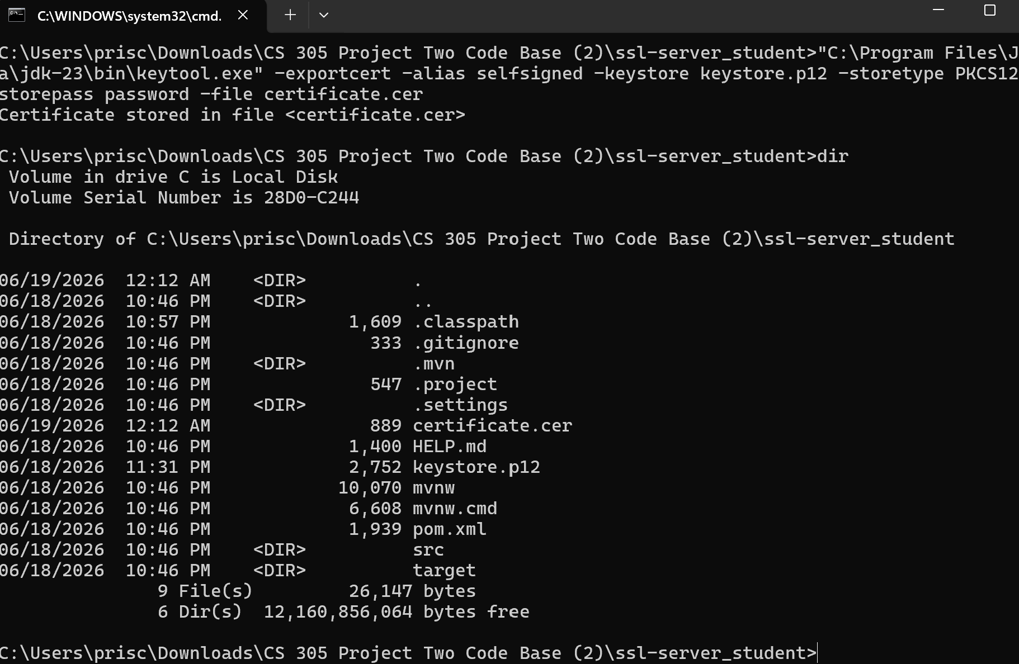

Deploy Cipher

The application was modified to generate a SHA-256 checksum for a unique data string containing the developer's name. This checksum allows users to verify that the transmitted data has not been altered.
Insert a screenshot below of the checksum verification.

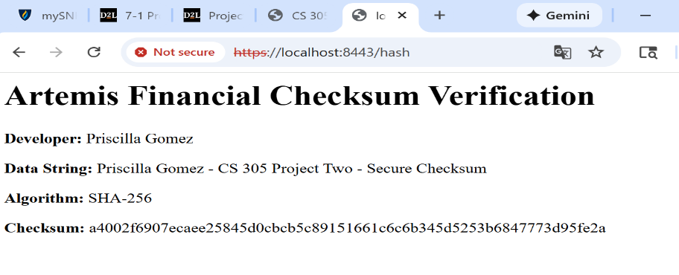

Secure Communications

HTTPS was successfully configured using a self-signed SSL certificate. The application now communicates securely over port 8443, encrypting all data transmitted between the client and the server.
Insert a screenshot below of the web browser that shows a secure webpage.



Secondary Testing

After refactoring the application, a secondary static analysis was performed using the OWASP Dependency-Check Maven plugin. The application was reviewed for known vulnerable dependencies to verify that no new security vulnerabilities were introduced during development.
Insert screenshots below of the refactored code executed without errors and the dependency-check report.
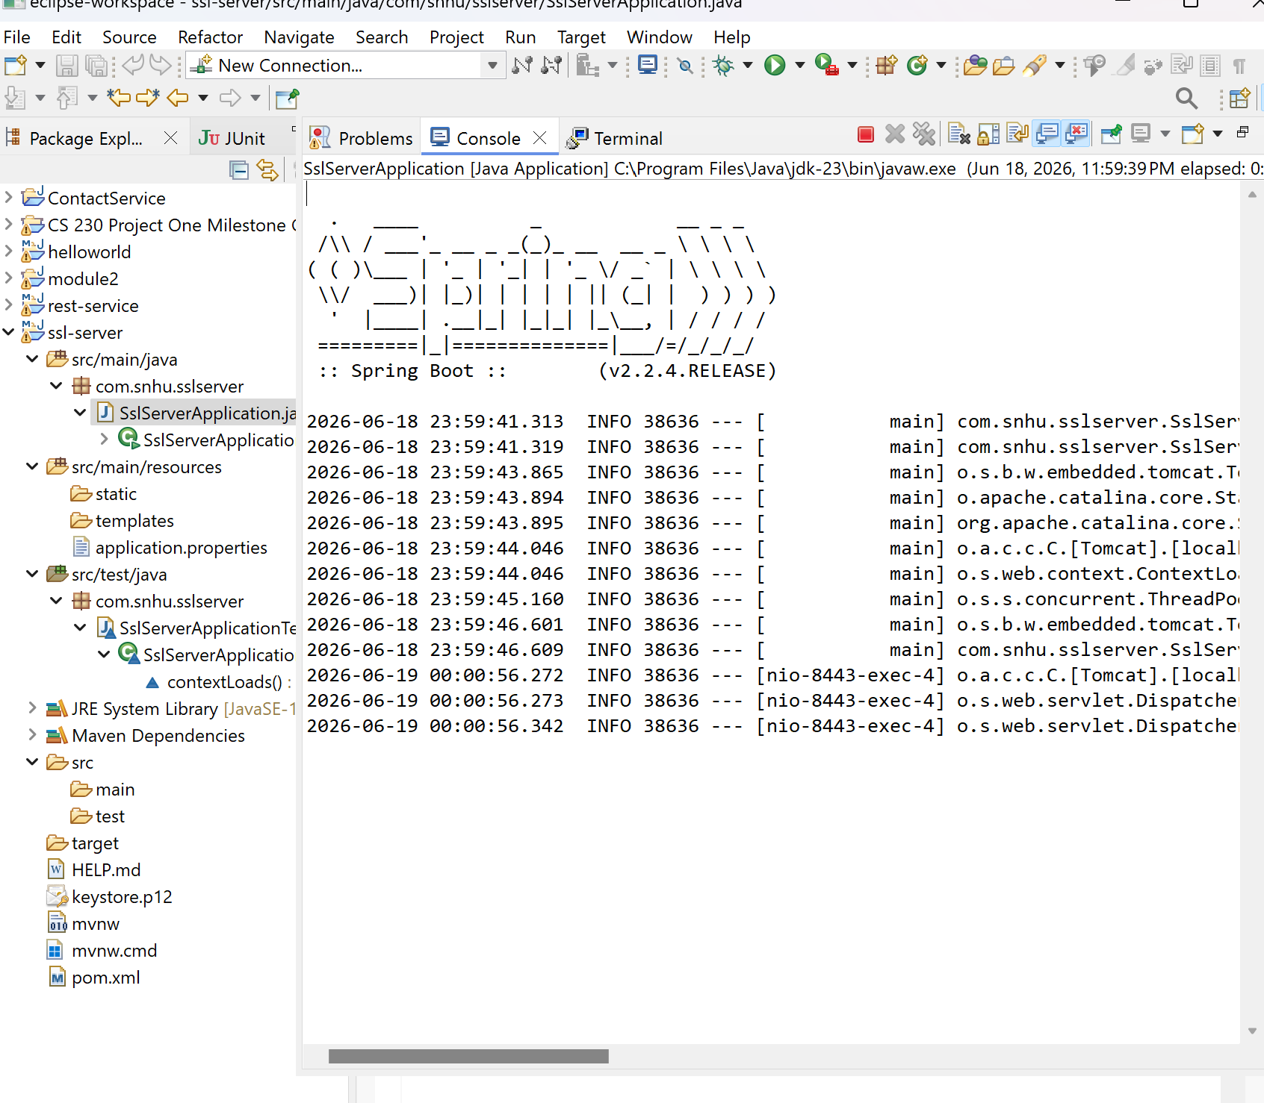

Functional Testing

Functional testing confirmed that the application executed successfully and that the checksum endpoint generated the expected SHA-256 hash. HTTPS communication functioned correctly, and the secure webpage displayed the checksum without runtime errors.
Insert a screenshot below of the refactored code executed without errors.


Summary

The Artemis Financial application was successfully refactored to improve software security by implementing multiple layers of protection. HTTPS was enabled using a self-signed SSL certificate generated with Java Keytool. SHA-256 hashing was implemented to verify the integrity of transmitted data through checksum verification.
Following the vulnerability assessment process, secure communications, cryptographic hashing, SSL certificate management, and dependency analysis were incorporated into the application. Static testing using OWASP Dependency-Check was performed to identify vulnerable third-party libraries, while functional testing verified that the application executed correctly after the security enhancements.
These improvements increased the application's confidentiality, integrity, and overall security while maintaining its existing functionality.

Industry Standard Best Practices

Several industry-standard secure coding practices were implemented throughout this project. HTTPS was enabled to encrypt all network communications using SSL/TLS. SHA-256 was selected as the cryptographic hash algorithm because it is widely accepted as a secure industry standard for checksum verification. RSA 2048-bit keys were used to generate the SSL certificate, providing strong asymmetric encryption.
Static analysis using the OWASP Dependency-Check plugin was performed to identify vulnerable third-party libraries before deployment. Functional testing verified that the application's security enhancements operated correctly without introducing new defects.
Applying industry best practices helps organizations like Artemis Financial reduce cybersecurity risks, protect sensitive customer information, maintain regulatory compliance, and improve customer confidence by ensuring secure software development practices.

